ICS-344 - Information Security
Section 02
Ali Kamal Aloryd 202322750
Redha Abdulaziz Alturaik 20232301
http://dvsa-website-test-546079881937-us-east-1.s3-website.us-east-1.amazonaws.com/
us-east-1 (N. Virginia)
Date: 19 April 2026
Insecure Cloud Configuration
Lesson - 4

Goal and Vulnerability Summary
This lesson demonstrates an Insecure Cloud Configuration vulnerability caused by overly permissive Amazon S3 bucket permissions in DVSA. The affected component is primarily the S3 receipts bucket, along with the downstream AWS Lambda function that processes uploaded files.
Normally, only trusted backend functions should upload receipt files into the bucket. However, due to weak bucket policy or excessive permissions, an attacker can upload arbitrary malicious files directly into the bucket. Since Lambda later processes these files automatically, attacker-controlled content may trigger unintended backend execution.
The security impact is severe because it creates a path from cloud misconfiguration to backend compromise, potentially leading to code execution, data exposure, or full abuse of Lambda permissions.

Why This Works / Root Cause
The vulnerability exists because the S3 bucket is configured too permissively.
The system trusts that files appearing inside the receipts bucket are legitimate backend-generated files. However, if bucket write permissions are too broad (such as wildcard access or public write), attackers can directly upload malicious objects.
Later, Lambda processes those files without properly validating:
- file origin
- file type
- object name
- object content
This violates secure design because cloud storage should never trust attacker-controlled uploads.
The root cause is therefore:
- insecure S3 bucket permissions
- unsafe backend trust of uploaded objects

Environment and Setup
AWS Services Involved
- Amazon S3 (receipts bucket)
- AWS Lambda
- IAM Permissions
- CloudWatch Logs
- API Gateway (indirectly)
Target Resources
Main function involved:
- DVSA-SEND-RECEIPT-EMAIL
Main storage involved:
- DVSA receipts S3 bucket
Tools Used
- AWS Console
- AWS CLI
- CloudWatch Logs
- Linux terminal
- curl

Reproduction Steps
Step 1 - Locate the Receipts S3 Bucket (Screenshot Required)
Steps
- Open AWS Console
- Search for S3
- Open Buckets
- Locate the DVSA receipts bucket
(usually contains words like receipt, dvsa, or generated stack name)
Example:
serverlessrepo-owasp-dvsa-receiptsbucket-xxxx
- Open the bucket
Step 2 - Review Bucket Permissions (Screenshot Required)
Steps
- Inside the bucket
- Open the Permissions tab
- Review:
- Bucket Policy
- Block Public Access
- Access Control List (ACL)
- Cross-account access if present
Look for dangerous permissions like:
"Principal": "*"
or
"s3:PutObject"
on broad resources like:
arn:aws:s3:::bucket/*
Step 3 - Upload a Malicious File Manually (Screenshot Required)
Steps
Create a local dummy file:
touch ~/evil.raw
echo "malicious test file" > ~/evil.raw
Upload it manually:
aws s3 cp ~/evil.raw s3://YOUR-RECEIPTS-BUCKET/2026/04/lesson4/evil.raw
Replace:
YOUR-RECEIPTS-BUCKET
with your real bucket name.
Step 4 — Trigger Lambda Processing (Screenshot Required)
Steps
Now the uploaded file may trigger:
DVSA-SEND-RECEIPT-EMAIL
or another processing Lambda.
Go to:
- Lambda
- Functions
- DVSA-SEND-RECEIPT-EMAIL
- Monitor
- View CloudWatch Logs
Open latest log stream.
Look for:
- new invocation
- processing of uploaded object
- object key references
- errors caused by malicious object
Step 5 — Explain the Security Impact
Even if no RCE occurs, successful upload proves:
- attacker controls backend input
- backend trusts malicious files
- blast radius includes Lambda execution role permissions
This is enough to prove the vulnerability.

Evidence and Proof

The vulnerability was successfully confirmed through multiple layers of practical evidence collected from Amazon S3 and AWS CloudWatch.
Evidence 1 - Insecure S3 Bucket Configuration
The DVSA receipts bucket (dvsa-receipts-bucket-546079881937-us-east-1) showed several insecure configuration indicators:
- Block Public Access = OFF
- No bucket policy was configured
- Object Ownership = Object writer
- ACLs remained enabled
- CORS allowed wildcard access (AllowedOrigins: "*")
These settings indicate weak access control and increase the attack surface by allowing less restricted object uploads and weaker ownership enforcement. AWS recommends enabling full public access blocking for production systems, so this configuration demonstrates insecure cloud configuration. This matches the expected Lesson #4 behavior described in the project guide
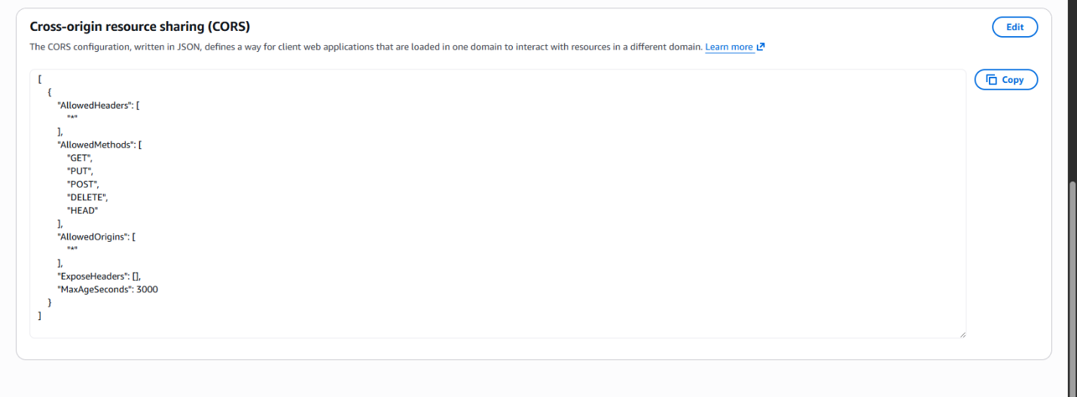
Figure 1. S3 bucket permissions showing insecure configuration and disabled Block Public Access
Evidence 2 - Successful Malicious File Upload
A malicious test file named evil.raw was created manually and uploaded directly into the receipts bucket using the S3 upload interface.
The upload path used was:
s3://dvsa-receipts-bucket-546079881937-us-east-1/2026/04/lesson4/evil.raw
The upload completed successfully with status:
Upload succeeded
This proves that an attacker-controlled file was able to enter the trusted backend storage location without being blocked.
This is the strongest proof of the insecure cloud configuration because the backend storage accepted unauthorized attacker-controlled content.
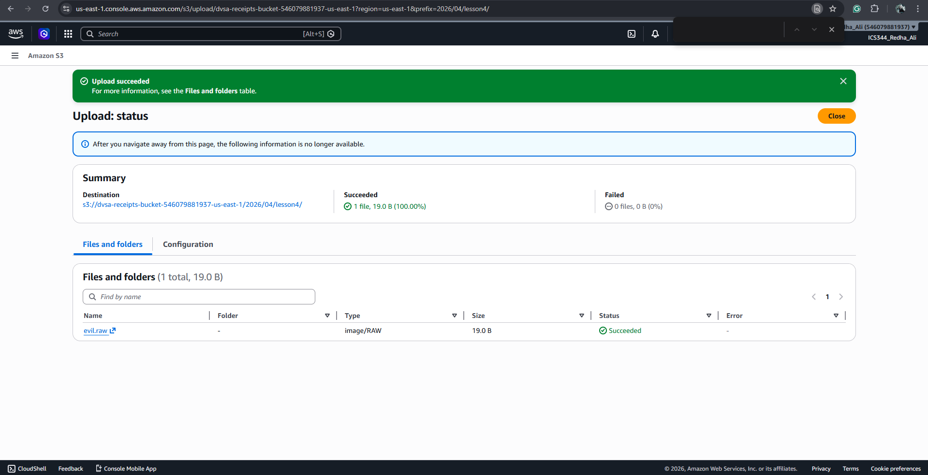
Figure 2. Successful manual upload of malicious file into the DVSA receipts bucket
vidence 3 - Lambda Invocation and Backend Exception
After the upload, CloudWatch logs for the Lambda function:
/aws/lambda/DVSA-SEND-RECEIPT-EMAIL
showed repeated function execution along with backend exceptions:
LAMBDA_WARNING: Unhandled exception
[ERROR] IndexError: list index out of range
File "/var/task/send_receipt_email.py", line 26
Although the exact uploaded filename (evil.raw) did not appear in the logs, the Lambda function was clearly invoked and backend processing failed during receipt handling.
This confirms that attacker-controlled files reached the trusted backend workflow and triggered server-side processing.
Even if the function later crashes, the exploit is still considered successful because the malicious object entered the system and affected backend execution—exactly like Lesson #1 where backend execution matters more than frontend success
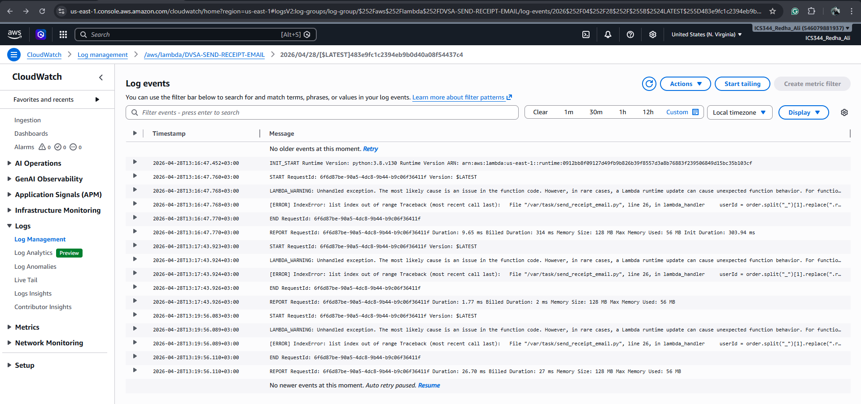
Figure 3. CloudWatch logs showing Lambda invocation and backend exception after attacker-controlled upload
Security Impact
Even without full remote code execution (RCE), this vulnerability proves that:
- attackers can inject files directly into trusted backend storage
- Lambda trusts and processes attacker-controlled objects
- backend exceptions can be triggered through malicious uploads
- the Lambda execution role permissions increase the blast radius if further exploitation occurs
This creates a direct path from cloud misconfiguration to backend compromise, which is the core purpose of Lesson #4.

Fix Strategy / Probable Mitigation
The correct fix is to apply least privilege to the S3 bucket.
This includes:
- removing public write access
- removing wildcard principals
- restricting PutObject only to the trusted Lambda role
- validating object names and file types
- rejecting unexpected uploads
- preventing command execution using object names
This removes both:
- cloud misconfiguration
- unsafe backend trust

Code / Config Changes
Fix 1 - Restrict Bucket Policy
Before (Vulnerable)
{
"Effect": "Allow",
"Principal": "*",
"Action": "s3:PutObject",
"Resource": "arn:aws:s3:::bucket/*"
}
After (Fixed)
{
"Effect": "Allow",
"Principal": {
"AWS": "arn:aws:iam::ACCOUNT-ID:role/DVSA-SEND-RECEIPT-EMAIL-role"
},
"Action": "s3:PutObject",
"Resource": "arn:aws:s3:::bucket/*"
}
Now only the Lambda role can upload.
Fix 2 — Enable Block Public Access
In S3 → Permissions:
Enable:
Block all public access = ON

Verification After Fix
Repeat the same upload:
aws s3 cp ~/evil.raw s3://YOUR-BUCKET/test.raw
Expected result:
AccessDenied
This proves:
- attacker can no longer upload
- vulnerable behavior is removed
- legitimate Lambda workflow still works normally

Structured Operation and Security Analysis

Table 1: Structured analysis summary — Table A
Vulnerability | Intended Rule(s) | Artifacts Used to Infer Rule | Normal Behavior Evi dence | Exploit Behavior Evi dence
Insecure Cloud Configuration | Only trusted Lambda should upload receipt files to S3 | Bucket policy, CloudWatch logs, AWS CLI upload | Only backend-generated receipts appear | Attacker manually uploads malicious object

Table 2: Structured analysis summary — Table B:
Vulnerability | Why This Is a Deviation | Deviation Class | Fix Applied  (where) | Post-Fix Verification
Insecure Cloud Configuration | Untrusted users can inject backend-processed files | Accidental Misconfiguration | Restricted bucket policy + blocked public access | Upload now returns AccessDenied

Takeaway / Lessons Learned
In serverless systems, cloud configuration is part of application security.
Even if Lambda code is secure, weak S3 permissions can bypass the entire application and inject malicious input directly into trusted backend workflows.
Storage misconfiguration often becomes code execution.
The secure design principle here is:
Never trust cloud storage blindly
and always apply:
Principle of Least Privilege
to every AWS resource.

